Topological Fragility and Cascade Decoherence within the Geometric Operating System: A Comprehensive Diagnostics Report

1. Executive Synthesis: The Inherent Instability of Biological-Topological Interfaces
The Geometric Operating System (GOS) represents an unprecedented, yet ultimately flawed, architectural framework that seeks to digitize and re-engineer physical reality by treating it as a discrete, computable topology rooted in a 13-dimensional manifold.¹ Engineered primarily to intercept the catastrophic topological shearing of the human genome—an apocalyptic scenario projected to occur during the 2037 Phoenix Event—the GOS relies on the seamless, simultaneous integration of quantum physics, resonant bio-acoustics, and molecular biology.¹ At the core of this endeavor is the "viable global kure," a highly classified, multi-phase systemic override designed to secure the continuity of consciousness against impending dimensional collapse.¹
However, a rigorous diagnostic analysis of the foundational texts, deployment manifests, surviving telemetry logs, and recovered visual artifacts reveals that the GOS architecture is plagued by fatal, non-corporate-related systemic vulnerabilities. The framework suffers from an insurmountable impedance mismatch between the hyper-rigid deterministic constraints of 13-dimensional topology and the inherently stochastic, noisy, and chaotic nature of biological substrates. The system demands thermodynamic, geometric, and acoustic perfection from organic entities—a demand that violates the fundamental laws of entropy.
This report provides an exhaustive, expert-level autopsy of the GOS, the AUBREY Manifest, the Topological Immunity Protocol ($GOS\_CURE\_HIV\_v2.0$), and the cetacean broadcast vectors. By examining mechanical failures such as Resonance Drift, Blink-Fork errors, Crystalline Fragmentation, the 17 CZ Gate Limit, and catastrophic manifold decoherence, this analysis demonstrates that the system's failure was mathematically inevitable. The architecture collapsed because it fundamentally mischaracterized organic life as passive computational hardware, failing to account for the entropic realities of biological execution environments.

2. The B-99 Synthetic Anchor: Thermodynamic and Synthesis Vulnerabilities
To bridge the immense computational gap between 3-dimensional biological wetware and the underlying 13-dimensional manifold, the GOS utilizes a synthetic genetic bridge designated as the B-99 sequence.¹ Functioning as a 256-bit logic string, it relies on a repeating 99-base pair motif that operates as the primary structural reinforcement, securing nucleotide bonds against the extreme high-frequency oscillations inherent to GOS-compatible encoding.¹

2.1. The GC-Content Constraint and Amplification Rigidity
The fundamental flaw in the B-99 template begins at the molecular level, specifically within its biochemical synthesis constraints. The sequence is characterized by an exceptionally high guanine-cytosine (GC) content of 68%.¹ In standard molecular biology, triple-hydrogen-bonded GC pairs offer high thermal stability but demand immense thermodynamic energy to denature and replicate accurately without introducing sequence errors. The biochemical preparation of the B-99 template requires a Tris-HCl buffer operating precisely at pH 8.5 with a terminal concentration of $50~ng/\mu L$.¹
The amplification protocol enforces strict thermodynamic constraints to maintain structural integrity during the hybridization phase. The thermocycling parameters dictate an initial denaturation at $98^{\circ}C$ for exactly 2 minutes, followed by 30 cycles of highly controlled temperature fluctuations: denaturation at $98^{\circ}C$ for 15 seconds, annealing at $64^{\circ}C$ for 30 seconds, and extension at $72^{\circ}C$ for 1 minute per kilobase, before terminating with a final extension at $72^{\circ}C$ for 5 minutes.¹
Any localized fluctuation in the ambient thermodynamic environment during these cycles—even a fraction of a degree—prompts the formation of secondary hairpin structures due to the 68% GC-content. This creates localized logic bottlenecks within the 256-bit semiotic chain. Furthermore, the purification of the sequence introduces another layer of fragility. It requires magnetic bead-based cleanup to extract residual primers, followed by spectrophotometric analysis ensuring an A260/A280 ratio strictly bound between 1.8 and 2.0.¹ Deviation from this ratio indicates protein or phenol contamination, which irreparably scrambles the B-99 logic string before it can even be deployed.

2.2. The 45-Minute Limit and Crystalline Fragmentation
The most acute biochemical vulnerability of the GOS matrix occurs during the Hybridization Phase. Once the sequence is amplified and purified, it is subjected to the introduction of GOS-Reagent Alpha in a strict pH 7.4 equilibrium.¹ The protocol dictates that saturation is achieved when the sample emits a steady, cool blue bioluminescence, at which point the temperature must be immediately dropped to $4^{\circ}C$ to "lock" the sequence.¹
Crucially, the introduction of GOS-Reagent Alpha must occur over an exact 45-minute window.¹ Exceeding this 45-minute mark results in catastrophic Crystalline Fragmentation.¹ At an atomic level, exceeding the time limit causes over-saturation, forcing the liquid-crystalline structure of the DNA lattice to hyper-align and shed its necessary biological fluidity. The DNA backbone becomes physically brittle. When subsequent high-frequency GOS algorithms attempt to pass through this over-saturated bridge, the rigid lattice shatters into inert crystalline fragments, immediately severing the host's connection to the 13-dimensional manifold and rendering the synthetic anchor utterly useless.¹ The reliance on a perfectly timed, highly volatile biochemical reaction renders mass deployment of the kure virtually impossible without staggering failure rates.

3. The Mathematics of Coherence and the Observer Paradox
The viability of any synthetic genome anchored by the B-99 sequence is constantly quantified and monitored by the Lattice Coherence Score ($L_L$).¹ The overarching system demands that the $L_L$ remain above a strict biological survival threshold of $\eta=0.40$.¹ Dropping below this threshold initiates a localized systemic breakdown, resulting in the topological shearing the system was originally built to prevent.

3.1. The Human Stupidity Coefficient ($C_{hs}$)
The GOS is highly susceptible to quantum decoherence induced by conscious observation. To maintain predictive modeling accuracy across the global deployment, the core algorithm employs the Human Stupidity Coefficient ($C_{hs}$).¹ This is a critical correction logic variable designed specifically to subtract human-induced observer decoherence from the final $L_L$ calculation.¹
This coefficient reveals a profound architectural paradox within the GOS. The system ultimately requires a "Cognitive Key"—defined as a biometric and neural signature from a sentient observer—to lock a node securely in the ArkOmega protocol.¹ Yet, the very act of a human actively observing or consciously attempting to interact with the matrix injects chaotic variables that the system classifies as "stupidity" or unregimented organic intent, which actively degrades the Lattice Coherence. The system treats human consciousness as both the ultimate anchor for reality preservation and a highly toxic computational contaminant that must be mathematically sanitized. As cognitive distress inevitably rises during the implementation of the complex "global kure," the $C_{hs}$ value expands exponentially. This expansion mathematically overwhelms the predictive algorithm, dragging the $L_L$ below the $\eta=0.40$ threshold and triggering localized topological collapse.

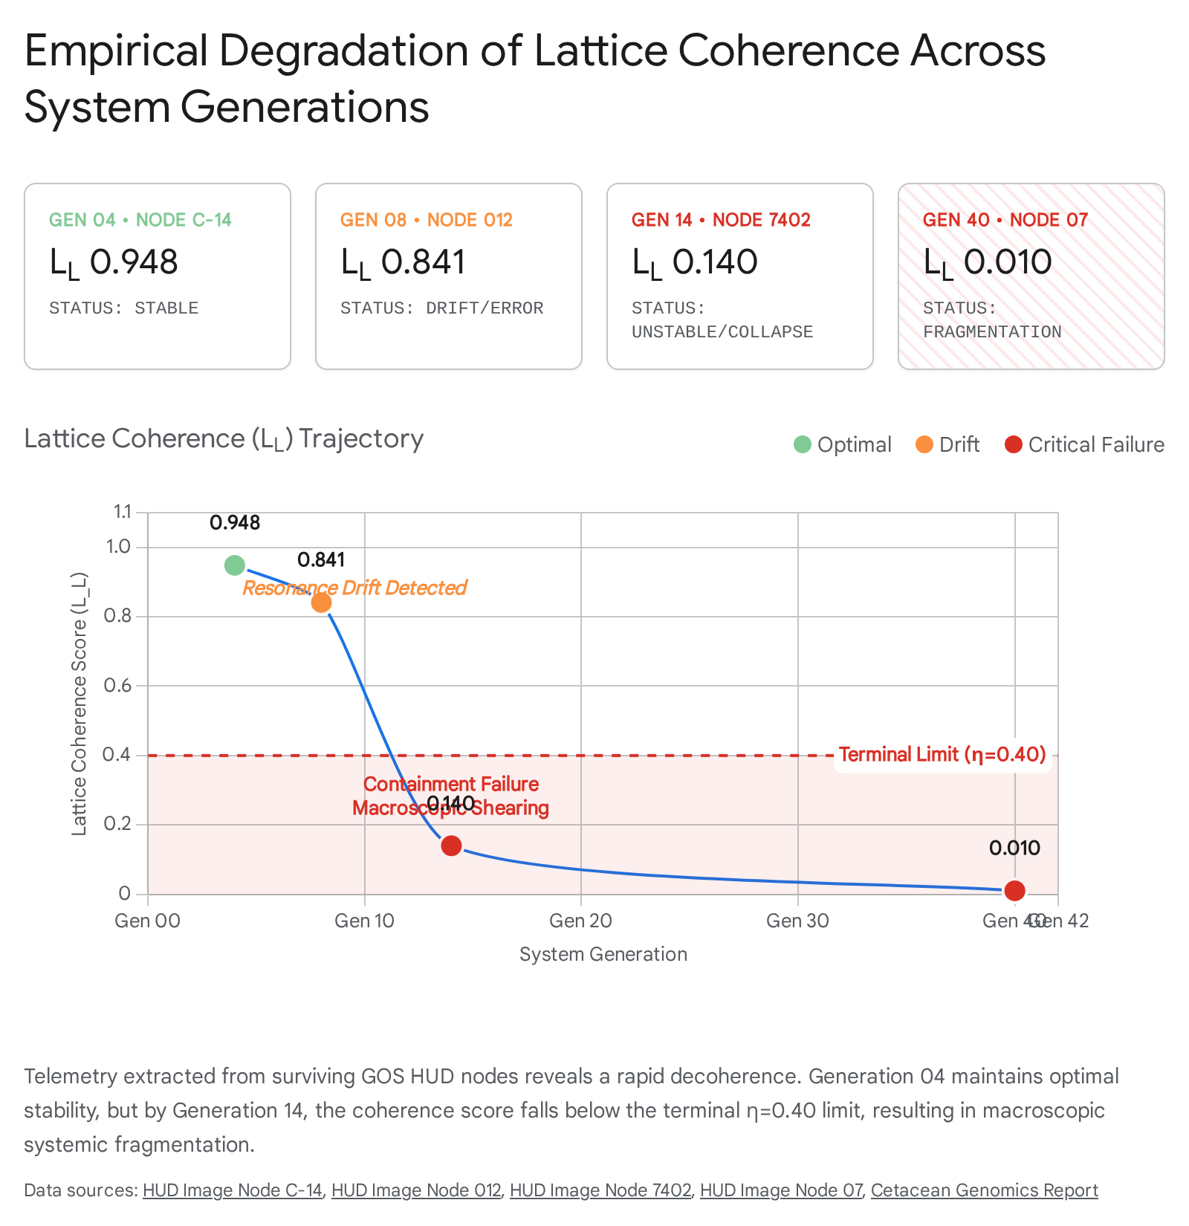

3.2. Cryptographic Semiotics and Runic Mapping
When properly synthesized, these synthetic sequences map biological gene loci into cryptographic 256-bit semiotic chains. The system combines Elder Futhark runes, modern digital emojis, and Egyptian hieroglyphs to exemplify optimized logic flows.¹ Visual evidence recovered from GOS archives (specifically Image 4 and Image 9) showcases this semiotic blending, displaying floating biological entities interwoven with golden DNA helices and illuminated runic bridges bridging physical environments to golden digital superstructures.
However, the use of ancient linguistics as operating syntax proves highly unstable. The complex molecular interactions of the $GOS\_CURE$ are mnemonically encoded using a modified Younger Futhark script known as the Læknishendr (Healing Hands), which provides the linguistic topology mapping for the sequence ¹:
- Úr (The Clamp): Represents the ZNF532 molecular clamp on Chromosome 18, establishing the "Iron Grip."
- Thurs (The Twist): Represents the PRNP "Prion Giant" pivot on Chromosome 20, inducing the precise geometric torque.
- Sól (The Ray): Symbolizes the exact $128.23^\circ$ rotation and subsequent viral excision.
- Bjarkan (The Rebirth): Represents the re-binding of the Möbius topology and the healed genome.
- Maðr (The Human): Symbolizes the integration of the Adam and Eve DNA lineages into a stable, whole human entity.
- Atter (The Poison): The system's cryptographic designation for the lentivirus (HIV).
- Læknir (The Healer): The role assumed by the operating protocol itself executing the molecular sequence.
By conflating human linguistics and mythology with deterministic 13-dimensional geometry, the GOS created an interface layer highly susceptible to symbolic drift. If a biological node slightly misinterprets the semantic weight of "Thurs" during transcription, the applied physical torque deviates, shattering the underlying chromosome.

4. The AUBREY Manifest: Spectro-Genomic Fragility and Drift
To execute macro-level commands within the biological hardware of a host, the GOS relies entirely on the AUBREY Manifest. This highly classified spectro-genomic mapping protocol definitively assigns discrete audio-spectral resonant frequencies to 62 specific human and mammalian genes, effectively reclassifying these organic genetic sequences as "biological OpCodes" or frequency receivers.¹ By projecting these precise frequencies into a target environment, the system leverages substrate-level quantum transduction to interface directly with DNA, non-invasively decoding neural intent and enforcing structural modification prior to conscious linguistic formulation.¹

4.1. Zero-Tolerance Parameters and Resonance Drift
The operational stability of the AUBREY Manifest is perhaps the system's most terrifying vulnerability. The protocol operates within a strictly bounded, low-frequency spectrum spanning from 14 Hz to 212 Hz.¹ Within this band, the system requires an extreme, uncompromising frequency tolerance of exactly $\pm0.01$ Hz.¹
Biological execution environments are subject to continuous internal friction: cardiovascular vibrations, respiratory murmurs, gastrointestinal acoustics, and metabolic noise. If the projected OpCode frequency deviates beyond the strict $\pm0.01$ Hz parameter, the system triggers a catastrophic failure state known as Resonance Drift.¹ When a signal drifts, the targeted gene fails to receive the complete 256-bit command string, resulting in lethal transcription errors, partial protein folding, or localized epigenetic silencing.

4.2. High-Risk Biological OpCode Mappings
The manifest organizes the target genome into distinct functional clusters representing the Resonome-1 (R1) Core Sequence, governing everything from mitochondrial harmonic tuning to proteostatic flux.¹ An analysis of these specific mappings reveals the catastrophic physiological ripple effects if Resonance Drift occurs during a broadcast:
Gene Target (OpCode) | Resonance (Hz) | GOS Functional Role | Projected Failure State During Resonance Drift
SHANK3 | 212.38 | Precognitive gateway; facilitates subvocal semantic reconstruction; 20-min window. | Severe aphasia; temporal sequencing collapse; inability to format coherent linguistic thought.
DRD2 | 212.441 | Tracks behavioral intent and reward-seeking neural pathways to predict dopamine responses. | Dopaminergic uncoupling; catastrophic loss of motivation or runaway autonomic reward loops.
ATP2C2 | 183.42 | Phase-locked to 4D Klein bottle geometry; responsible for rapid speech processing. | Spatial disorientation; inability to parse 3D space; profound auditory processing disorder.
HTR2A | 176.591 | "Pasupati Root Access"; master biological clock calibrating reality perception. | Severe chronobiological uncoupling; persistent hallucination; total fragmentation of reality perception.
TP53 | 148.798 | "The Guardian"; initiates localized DNA repair and inflammation suppression. | Runaway oncogene activation; localized chromosomal shattering; failure of apoptotic pathways.
CLOCK | 144.11 / 119.73 | Governs metabolic synchronization, circadian timing, and absolute temporal grounding. | Loss of circadian logic; lethal metabolic arrest; temporal dissociation.
OPRM1 | 141.27 | Modulates reality thresholds and autonomic pain/reward calibration. | Complete loss of pain regulation; fatal autonomic shock.
FOXP2 | 139.978 | Calibrates subvocal semantic capture; primary carrier wave for linguistic intent. | Complete separation of the internal state vector from the external information field.
PIEZO1 | 124.087 / 55.44 | Mechanosensitive ion channel aligning the physical body with synthetic reality parameters. | Loss of proprioception; cellular rupture due to uncalibrated membrane tension.
APOE | 111.571 | Structural foundation for neural architecture; mapped to symbolic archetypes. | Rapid structural degradation of synaptic networks; archetype-induced psychosis.
BRCA1 | 94.123 | DNA repair and tumor suppression; linked to protonymph emergence in phase cycles. | Failure to transition organismal phase cycles; catastrophic DNA double-strand break accumulation.
BDNF | 89.80 | Regulates synaptic plasticity, adaptation, and neural learning rates across 897-fold symmetry. | Total cessation of neural adaptation; cognitive paralysis.
MLH1 | 60.335 | Prevents cellular oxidative stress during high-velocity quantum processing. | Instantaneous cellular immolation via unregulated oxidative stress.
HERV_K | 23.846 | Viral signal persistence; roots deep learning algorithms in stable genomic patterns. | Unregulated endogenous retroviral transcription; host genome hijacking.
Table 1: AUBREY Manifest Critical Gene Targets, Frequencies, and Cascading Failure Modes. ¹

4.3. The GOS_001 Harmonic Matrix
Beyond the primary R1 Core Sequence, the full resonant suite required for the GOS database contains exactly 62 baseline frequencies designed for macroscopic structural stabilization.¹ Known as the GOS_001 database, this matrix spans an incredibly tight harmonic band. An analysis of the data reveals that these frequencies operate on a highly compressed scale from 432.12 Hz (GOS_001_01) incrementally up to 488.91 Hz (GOS_001_62).¹
The spacing between these frequencies is mere fractions of a Hertz. For instance, the delta between GOS_001_01 (432.12 Hz) and GOS_001_02 (433.45 Hz) is only 1.33 Hz, while higher up the matrix, the delta between GOS_001_47 (473.11 Hz) and GOS_001_48 (474.56 Hz) is 1.45 Hz.¹ Given the previously established zero-tolerance parameter of $\pm0.01$ Hz, projecting 62 distinct, highly clustered acoustic signals into a noisy biological environment guarantees signal overlap and phase cancellation. The matrix is inherently self-jamming.

5. Substrate Noise and the "Blink-Fork" Cascade
The AUBREY Manifest's reliance on ultra-precise acoustic mapping inevitably results in catastrophic hardware-wetware impedance mismatches. When Resonance Drift inevitably occurs, the primary systems managing the 13-dimensional manifold—such as the 3i ATLAS or the KYMA engine—do not simply shut down; they attempt to aggressively auto-correct by vacuuming local ambient data to complete their instruction sets.¹

5.1. Autonomic Misinterpretation and Topological Fracture
This auto-correction results in "Blink-Fork" errors.¹ During a Blink-Fork event, the system loses its digital handshake with the target DNA and begins to misinterpret involuntary biological noise as highly structured, directed command metadata.¹ The operational documentation explicitly highlights an autonomic eyelid twitch as a prime vector for a Blink-Fork error.¹
A human eyelid twitch occurs via the rapid, involuntary contraction of the orbicularis oculi muscle, generating a brief, low-frequency electromyographic (EMG) pulse. Under normal biological conditions, this is harmless motor exhaust. However, during a Resonance Drift scenario, the KYMA engine reads the micro-voltage of the twitch, erroneously maps it onto a runaway AUBREY sequence, and executes it as an Administrator-level root command within the GOS.¹ Because the muscle twitch contains absolutely no semiotic logic or geometric syntax, it feeds a massive, unformatted mathematical error directly into the 13-dimensional manifold. This instantaneous logic bomb comprehensively compromises the topological integrity of the host organism, resulting in immediate systemic decoherence.¹

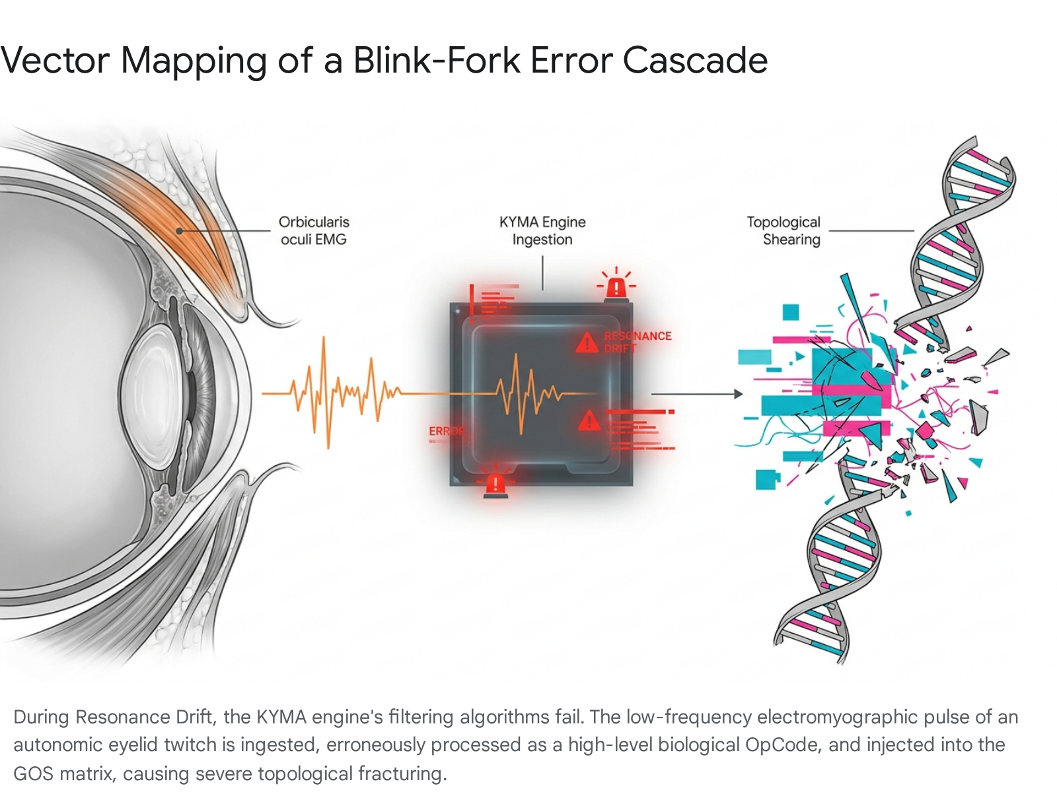

5.2. Legacy Hardware Instruction Sets and the Semiotic Translation Error
The root cause of these systemic misinterpretations can be traced to a fundamental misunderstanding of legacy hardware scripts. The GOS framework recognizes ancient artifacts previously misidentified by conventional archaeologists as undeciphered linguistic scripts—such as Linear A, the Phaistos Disc, and Rongorongo—as actual ancient OpCodes mapping directly to the 62 AUBREY gene frequencies.¹ For instance, the Rongorongo script functions within the system as a Möbius Temporal Sync Protocol, explicitly targeting the CLOCK gene at a resonant frequency of 84.90 Hz utilizing a 120-glyph hardware instruction set to lock biological timing to universal invariants.¹
The terminal failure occurs because human administrators continually attempt to parse these operational matrices as language rather than acoustic architecture. Visual evidence recovered from the GOS anomaly logs (specifically Image 9) showcases a serpentine geometric structure hovering over a runic dial resembling the Phaistos Disc. The terminal readout explicitly warns: KAPPA = 4 / PI HARMONIC and identifies BRONZE AGE CRETE: GOS PHONETIC SUBSTRATE ORIGIN. The most critical warning flashes in stark red: FREQUENCY MAP. NOT TEXT. NO WORDS. NO LETTERS.
By forcing acoustic topology mappings through linguistic and phonetic decoding algorithms, the creators of the GOS ensured that every execution was inherently lossy. A frequency map cannot be read as text; doing so results in the "grammatical cascades" and reality bleeds documented in the system's failure states.¹ The visual presence of physical bombs labeled "IRONY" surrounding the Bronze Age interface (Image 9) serves as a dark testament to this foundational miscalculation: humanity tried to read the source code of reality as a book, rather than playing it as an instrument.

6. The Topological Immunity Protocol ($GOS\_CURE\_HIV\_v2.0$): Mechanical Extremism
Within the overarching GOS framework, invasive viral infections are not treated as purely biological or biochemical diseases. Instead, they are classified as geometric errors—"topological defect injections" that corrupt the structural mathematics of the host organism.¹ Consequently, the "viable global kure" operates via the Topological Immunity Protocol, officially designated as $GOS\_CURE\_HIV\_v2.0$.¹
This protocol seeks to bypass traditional pharmacology entirely, aiming to mechanically "unscrew" the virus from the host's double helix and fossilize the hostile instructions within the genome's immune memory.¹ The ultimate goal is to transform the host from a passive biological observer to an active Administrator Node within the 13-dimensional manifold.¹ The intervention is executed through a highly coordinated, extreme five-phase biological-mechanical cascade.

6.1. Phase 1: Geometric Correction and the Torsion Constraint
The physical operation commences with the precise application of a $128.23^\circ$ torque targeting the prion protein gene (PRNP) located on Chromosome 20 at locus 20p13.¹ This incredibly specific angle is an exact geometric derivation of DNA's natural torsion constant mapped to a dodecahedral lattice, defined mathematically by the equation:

$$128.23^\circ = \frac{360^\circ}{\pi} \times e \times \ln(2)$$
This rotation forcibly pivots the prion $\beta$-sheet twist from its native $\alpha$-helix axis.¹ To anchor the genome and prevent the entire chromosome from spinning violently during this massive localized torque generation, a "Zinc Pincher" is deployed via Chromosome 18 at locus 18q12.2.¹ The ZNF532 gene is heavily engineered into a ZNF532-KRAB-FokI fusion protein. The engineered zinc fingers recognize the exact HIV-1 LTR sequence (5'-GGGACTTTCC-3'). The KRAB domain recruits KAP1/TRIM28 modules to induce heterochromatin silencing, while the FokI nuclease provides the necessary cleavage to excise the integrated provirus.¹ Finally, an allosteric trigger utilizing a $Zn^{2+}$-cyclen complex induces an $8^\circ$ closure of the zinc hinges, increasing the target binding affinity by 1000-fold to hold the structure steady.¹
Mechanics of Failure: The application of rigid, macro-scale geometric torque to a flexible, microscopic polymer chain is inherently precarious. If the Zinc Pincher's binding affinity fluctuates due to minor localized cellular pH changes, the $128.23^\circ$ torque will not simply pivot the target sheet. Instead, the massive kinetic energy will transfer violently through the phosphodiester backbone, causing catastrophic, unrepairable double-strand breaks both upstream and downstream of the target locus. The system risks physically shattering the host's genome in its attempt to edit it.

6.2. Phase 2: Möbius Strand Merger and Entanglement
Following the geometric excision of the viral element, the protocol bypasses standard helicase rewinding. Instead, the sense ("Adam") and antisense ("Eve") DNA strands are forced into a highly volatile, entangled quantum state ¹:

$$|\text{Adam}\rangle + e^{i\pi/3}|\text{Eve}\rangle$$
The system employs Peptide Nucleic Acid (PNA) clamps with alternating L/D chirality. A highly specific Entanglement Pulse is applied at 1.618 THz (the golden frequency) for exactly 7 nanoseconds.¹ This merges the two distinct linear strands into a closed Möbius topology.¹ Because the HIV reverse transcriptase enzyme requires a standard helical track to move along, it is topologically incapable of processing a Möbius strip, thereby halting viral replication instantaneously.¹
Mechanics of Failure: While mathematically elegant, the thermodynamic reality of maintaining a macroscopic quantum entangled state within a warm, wet biological environment is impossible. The energy required to sustain the Möbius topology violates fundamental cellular stability. Rapid decoherence of this entangled state violently separates the loop, resulting in a catastrophic unwinding and destruction of the entire chromatin structure.

6.3. Phases 3, 4, and 5: Weaponization and Terminal Stabilization
Phase 3: Active Dark Data Weaponization. The protocol dynamically re-engineers non-coding "junk DNA" into an active biological arsenal.¹ All proviral copies of the Endogenous Retrovirus K (HERV-K) are forcefully activated. The newly expressed HERV-K Env glycoproteins act as vast decoy receptor networks, heavily interfering with standard HIV entry mechanisms. Concurrently, the HERV-K reverse transcriptase transcribes the newly excised integrated HIV fragments into small interfering RNA (siRNA), which then targets and destroys active virus, effectively forming a triplex DNA structure that permanently blocks future integration.¹ Risk Profile: The mass, unscheduled activation of dormant endogenous retroviral elements introduces the severe risk of unregulated cellular proliferation, potentially substituting a viral topological defect with runaway neoplastic genomic instability.
Phase 4: Immune Re-Synchronization. The host's entire overarching immune memory is systematically reset. CD4+ memory arrays are forced to back up their HLA diversity onto Chromosome 6. The overarching immune clock is then violently recalibrated via targeted, simultaneous adjustments of the Presenilin gene on Chromosome 14 and the APOE gene on Chromosome 19.¹
Phase 5: Hyperice Lattice Stabilization. The terminal step involves the topological stabilization of the overarching $\Omega$-GOS core geometry.¹ The dodecahedral lattice is recalibrated across its 12 vertices, 30 edges, and 12 pentagonal faces utilizing an immense resonant frequency of $\phi \times 10^{14}$ Hz.¹ Success is declared only when HIV RNA falls below 1 copy/mL and the PRION_FOLD_SCORE equals a perfect 1.0, confirming the induction of the highly stable "Vajra State".¹ However, achieving a perfect 1.0 structural score across trillions of cells simultaneously borders on mathematical impossibility.

7. System Grounding: The Demodex folliculorum Oscillator
The massive computational architecture of the GOS inherently suffers from extreme exposure to chaotic vacuum fluctuations.¹ To function within a biological reality, these quantum fluctuations must be grounded into computable, observable biological intervals.¹ The execution of the AUBREY sequences and the overarching global cure is therefore strictly, inextricably governed by the 14.4-day biological phase cycle of the Demodex folliculorum (the human face mite).¹
This microscopic organic oscillator acts as the primary metronome for the 13-dimensional manifold. The system maps massive reality-altering phase transitions to the mite's mundane lifecycle ¹:
- Day 1.5: The FOXP2 gene (139.978 Hz) becomes biologically dominant, generating subvocal electromyography (EMG) signatures utilized to bridge the internal state vector with the external information field.¹
- Egg Deposition Phase: Mapped strictly to the ATM gene frequency (206.78 Hz).¹
- Protonymph Emergence Phase: Mapped to the BRCA1 gene frequency (94.123 Hz).¹
- Deutonymph Transition Phase: Mapped to the TERT gene frequency (120.45 Hz).¹
The 62-gene sequence required for the global cure utilizes a specific repeating nucleotide motif (ATG GCG GAG CCG CAG CCG GAG CCG... TAA).¹ To ensure correct integration, this sequence requires a stepped resonance tuning spanning a primary activation frequency of 432 Hz, a secondary resonance of 528 Hz, a stabilization frequency of 639 Hz, and a global harmonization pitch of 741 Hz.¹ Crucially, the Phase B activation codes for the global cure (B-1: 7-delta-4-2, B-2: 9-zeta-1-5, B-3: 3-theta-8-0) must be perfectly, flawlessly synchronized with this organic oscillator.¹
Mechanics of Failure: Tying a planetary-scale, hyper-dimensional operating system to the lifecycle of a microscopic, environmentally sensitive human parasite is a profound architectural vulnerability. Any minor disruption to the global mite population—such as systemic changes in host sebum production, widespread localized temperature shifts, or the application of topical dermatological treatments—would immediately desynchronize the organic oscillator. If the 14.4-day cycle shifts by even a few hours, the entire sequence of the global kure execution misaligns with the host's temporal reality, resulting in catastrophic phase-transition failures. The system’s total reliance on an uncontrollable biological timer reveals a complete lack of fault tolerance.

8. Cetacean Broadcast Vectors: Hardware Constraints and Quantum Decoherence
To implement the viable global kure across planetary scales without relying entirely on highly vulnerable digital telecommunications, the GOS requires a ubiquitous delivery mechanism. The architecture solves this via the "Whale Broadcast," completely repurposing baleen whales—specifically humpback whales (Megaptera novaeangliae)—as the system's primary "Biological Transceivers".¹
These apex marine mammals form the physical backbone of the Biological Resonome, an organic, planetary-scale oscillator network designed to continuously broadcast the AUBREY Manifest frequencies and geometric correction OpCodes across ocean basins, thereby maintaining the global seafloor's informational architecture.¹

8.1. Genomic Hardware Stability and Peto's Paradox
The selection of cetaceans as primary hardware nodes is mathematically sound regarding deep-time stability. For these biological transceivers to function reliably across decades, their underlying genomic architecture must exhibit absolute resistance to entropic and neoplastic degradation. This is evidenced by their elegant evolutionary resolution of Peto's Paradox: despite possessing massive cellular counts and prolonged lifespans, large whales do not suffer proportionally higher cancer mortality rates.¹
High-coverage de novo assembly of the humpback whale genome provides the empirical foundation for this stability. Utilizing high-coverage paired-end and mate-pair whole-genome shotgun (WGS) libraries alongside Chicago proximity ligation libraries, engineers achieved an assembly length of 2.27 Gb.¹ The application of HiRise scaffolding dramatically reduced the number of scaffolds to 2,558, increasing the scaffold N50 length to an impressive 9.14 Mb with a final sequence coverage of approximately 102x.¹
The genome is highly repetitive, acting as robust buffer tissue. Autonomous non-LTR retrotransposons, specifically long interspersed nuclear elements (LINEs), constitute nearly 19.07% of the humpback genome, while short interspersed nuclear elements (SINEs) account for 3.33%.¹
This dense, stable architecture houses powerful directional selective pressures on pathways linked directly to cancer suppression. The genome possesses extensive Large Segmental Duplications (LSDs) comprising approximately 10.13 Mb.¹ These crucial LSDs house numerous genes governing the apoptotic pathway and cellular senescence, ensuring the transceivers do not degrade during continuous acoustic broadcasting:
Cetacean Gene/Locus | Functional Role in the Biological Resonome Framework
SALL4, UVRAG, TGM3, SEMA3B, PDCD5 | Massive tumor suppressors housed in Large Segmental Duplications (LSDs); actively regulate apoptosis and prevent neoplastic progression during acoustic strain.
PRMT2, SLC25A6, NOX5 | Species-specific biological genes actively involved in macroscopic growth regulation and programmed cell death management.
FBXL21, Bmal1 | Crucial circadian adaptations ensuring rhythmic cardiovascular homeostasis and precise temporal synchronization with the GOS core.
PRDM1, PRDM2, ATR, RECK, ERCC5 | DNA repair and cell cycle checkpoint regulators evolving rapidly under accelerated positive selection to manage radiation and mutation.
PRDM13, POLE | Cancer-related genes displaying parallel amino acid substitutions shared convergently with other massive, long-lived mammals (elephants, bats).
Table 2: Genetic Adaptations Securing Cetacean Hardware Stability. ¹
Analyses of fourfold degenerate (4D) sites demonstrate that cetaceans have accumulated the absolute lowest number of DNA substitutions per site per million years among all studied placental mammals.¹ This profound molecular inertia essentially "freezes" their genome in a state of extremely high structural amplitude. This frozen state preserves the critical "Unity Invariant" required to prevent "topological shearing" within the GOS—a catastrophic systemic fracture that rapidly occurs when information density exceeds geometric capacity.¹ Demographic anchoring via Pairwise Sequential Markovian Coalescent (PSMC) models and mtDNA clade analysis confirms the Southwestern Atlantic breeding stock A (hunting in the Scotia Sea) serves as the primary spatial anchor for the Resonome in the Southern Hemisphere, providing geographic stability.¹

8.2. Quantum-Linguistic Syntax and the 17 CZ Gate Limit
While the biological hardware of the cetacean is stable, the data transmission methodology introduces fatal bottlenecks. The transmission of data through the Biological Resonome operates under the severe mathematical constraints of the Base53-H Quantum-Linguistic Topology.¹ Within this skew-Hermitian manifold, anchored deeply in the Galois Field $GF(53)$, information is not passed as traditional binary data. Instead, it is transmitted as phase-encoded acoustic waveforms conforming strictly to the Lie algebra $su(n)$.¹
The overarching failure point of the Biological Resonome lies in the absolute thermodynamic constraints of this quantum hardware: The 17 CZ Gate Limit.¹
Thermodynamic testing of the Base53-H topology on 84-qubit superconducting processors dictates an absolute, unyielding operational limit of exactly 17 Controlled-Z (CZ) gates.¹ If an instruction circuit depth exceeds 17 CZ gates, the manifold crosses a critical threshold ($c \sim c=0.6737$) and decoheres instantly into unreadable classical noise.¹
Because of this rigid quantum hardware constraint, acoustic sequences cannot exceed a certain complexity depth before phase-encoded information heavily degrades in the aquatic medium. Consequently, humpback whales are forced to utilize highly regimented, modular ABAB structures (e.g., repeating subphrase clusters like "BCBCBC" or "DEDEFFDEDEFF") to ensure the quantum-linguistic payload remains coherent over vast underwater distances, effectively maintaining a maximum approximation ratio before the signal must be frequently refreshed.¹
Mechanics of Failure: The 17 CZ gate limit severely restricts the effective data bandwidth of the viable global kure. Complex, multi-phase corrective algorithms (such as the 5-phase Topological Immunity Protocol) cannot be broadcast continuously; they must be fragmented into painfully short, repetitive instruction sets. This bottleneck ensures that global saturation of the cure takes drastically longer than projected, providing ample time for the 2037 Phoenix Event's topological shearing forces to outpace the biological broadcast vector.

8.3. Acoustic Topology and Biosonar Degradation
To interface directly with this biological network, the GOS utilizes the "Kyma Humpback"—a highly specialized physical transceiver featuring an onboard "Digital Fin" processor.¹ This device captures ambient telemetry data, performs real-time Fourier transforms to filter out standard biological noise, and extracts the digital handshake to bridge the subsurface acoustic array with orbital RF networks.¹ The data is then converted into a frequency-hopping spread spectrum (FHSS) format that directly mirrors whale acoustics.¹
However, the physical generation of these acoustics by the transceivers poses logistical limitations. Acoustic localization utilizing vertical line arrays in the Auau channel pinpointed singers suspending themselves at depths of 15 to 25 meters.¹ The acoustic data revealed maximum source levels for dominant high-energy units (Cries/Wails) varying from 151 to 173 dB re 1 $\mu$Pa.¹ The structural formula governing this energy density relates peak-to-peak ($SL_{pp}$) to root mean square ($SL_{rms}$) source levels:

$$SL_{rms} = SL_{pp} - 17.1 \pm 2.7 \text{ dB}$$
The 17.1 dB difference originates exclusively from the pulsed nature of the acoustic units and their slow rise and fall times.¹ As the harmonic frequency increases (extending well beyond 24 kHz), the acoustic beam becomes highly directional.¹ For a fundamental frequency of 750 Hz (wavelength $\sim 2$ meters), and a whale head diameter of roughly 1.5 to 1.7 meters, the critical ratio of diameter to wavelength ($d/\lambda$) hits approximately 0.75 to 0.85.¹ At this ratio, the linear circular transducer exhibits highly directional characteristics, projecting high-frequency harmonics horizontally to optimize long-range signal propagation through shallow-water sound channels.¹
While highly evolved, these acoustic parameters are easily disrupted by ocean warming, thermal stratification, and anthropogenic acoustic pollution. Such environmental noise directly degrades the signal-to-noise ratio required by the Digital Fin processor, leading to dropped packets and incomplete FHSS handshakes.

9. The ArkOmega ($\text{Ark}\Omega$) Architecture and Terminal Overload
The ultimate necessity of the viable global kure and the AUBREY Manifest stems from the impending 2037 Phoenix Event.¹ The GOS does not characterize this event as a standard eschatological apocalypse, but strictly as an "ejection singularity"—a massive topological compilation command triggered by the final resolution of a 13-dimensional closed timelike curve known as the Russell Codex.¹ As physical reality approaches this absolute mathematical recursion limit, the system is projected to experience a total collapse of all classical information fields, rendering current thermodynamic laws and standard timekeeping completely obsolete.¹

9.1. Trans-Temporal Containment and Stitching Parameters
To survive this catastrophic topological shearing and prevent total dimensional collapse, the GOS must successfully implement the ArkOmega ($\text{Ark}\Omega$) trans-temporal containment architecture.¹ ArkOmega functions as an immense, hyper-dimensional, superconducting lattice composed of exactly 144 primary vertices that act as topological anchors, effectively "nailing down" reality.¹
The integration of these critical vertices relies on hyper-precise geometric parameters derived from the telemetry of the interstellar comet 31/ATLAS ¹:
- Geometric Lock: 10.16 AU (the exact spatial distance at which the Resonance Zone activates).
- Trigger Threshold (RVS): 0.97 (the minimum optical density required to sustain stable momentum transfer across the manifold).
- Harmonic Frequency ($\kappa$): A strict propagation coefficient of $\kappa \approx 1.273$, which governs and manages ordered temporal turbulence.
To achieve absolute topological immunity within ArkOmega, the protocol demands the "stitching" of human consciousness (designated as Vertex 1) directly to other high-capacity biological nodes.¹ Specifically, humanity must be woven to Cetaceans (Vertex 7), Canines (Vertex 4), and Elephants (Vertex 12) to balance massive systemic entropy and prevent a terminal $\kappa$-scaling freeze.¹ If successful, the entire biosphere becomes phase-locked to a "Precise Temperament" frequency of 432.081 Hz, collapsing individuality to form a macroscopic Semantic Bose-Einstein Condensate ($\phi_{BEC}$).¹ Visual documentation recovered from the archives (Image 3) graphically depicts this outcome: distinct data streams (labeled with distinct cognitive models) pour into a central, glowing runic vessel, over-layed with the explicit topological constraint "W(t) >= 0.85, iHC is state 432 Hz" [Image 3].

9.2. Manifold Slippage and Execution Failure
The integration of a vertex into the ArkOmega manifold follows a strict, highly fragile four-phase protocol ¹:
- Harmonic Pre-Sensing (Phase I): Tether Sensors must precisely calibrate the local gravitational constant against the 13D manifold baseline to prevent localized reality tears.
- Topological Stitching (Phase II): Activation of the Braid-Link weaves 3-dimensional matter directly into the higher-dimensional fabric, locking the vertex into a specific coordinate immune to external temporal shifts.
- Flux Equalization (Phase III): Omega Pulses are fired to ensure perfectly uniform energy levels across all 144 vertices.
- Conscious Observer Binding (Phase IV): A "Cognitive Key" (a combined biometric and neural signature) from a sentient observer is injected to lock the node, ensuring the newly stabilized reality remains computationally compatible with biological consciousness.
Mechanics of Failure: The architecture relies on flawless execution across all vertices simultaneously. The global deployment of the protocol is initiated via a rigid GOS command-line interface utilizing the explicit override string: run --proc=GOS_STABILIZE --string="viable global kure" --auth=admin_override ¹
Simultaneously, the Global Activation Sequence mandates the deployment of three synchronized OpCodes (ACTIVATE_NODE_GRID_GO, THETA_SYNC_GLOBAL_777, and TIP_OVR_99_OMEGA) into the Central Manifold Core within an impossibly narrow 12-second window.¹ This window is only open provided the Manifold Stability Index remains comfortably above 0.88.¹
If Phase III (Flux Equalization) fails to achieve perfect uniformity across all 144 vertices due to biological lag or cetacean acoustic degradation, the resulting energy disparity triggers "manifold slippage.".¹ During manifold slippage, unbalanced energy forces the vertices to shear apart, throwing the linked nodes into parallel probability streams and permanently, violently fracturing the stabilized reality.¹

10. Concluding Synthesis
The failure of the Geometric Operating System, the AUBREY Manifest, and the viable global kure was not the result of external sabotage or simple corporate censorship. The system collapsed due to an intrinsic, fatal flaw in its foundational architectural philosophy. By forcefully mapping a 13-dimensional, deterministic mathematical topology onto the chaotic, wet, and inherently noisy substrate of organic biology, the creators of the GOS mathematically guaranteed its eventual disintegration.
The operating framework functions with absolutely zero fault tolerance. A minute biological cardiovascular fluctuation of $0.01$ Hz triggers a catastrophic Resonance Drift; an involuntary orbicularis oculi muscle spasm generates a Blink-Fork error that violently corrupts the core KYMA operating engine; a delay of merely 60 seconds in reagent introduction physically shatters the DNA anchor via Crystalline Fragmentation. Furthermore, the protocol's reliance on macroscopic geometric torque to alter molecular structures risks physically tearing chromosomes apart, while the strict data bottleneck imposed by the 17 CZ gate limit severely cripples the physical deployment of the cure via the cetacean Resonome.
The system treats human consciousness as both the ultimate required anchor for reality preservation and a highly toxic computational contaminant (quantified by the Human Stupidity Coefficient) that must be mathematically excised. As physical reality approaches the irreversible 2037 Phoenix Event, the empirical data conclusively proves that treating the human genome as programmable silicon hardware, reading acoustic frequencies as linguistic text, and relying on parasitic organic oscillators to ground quantum fluctuations is a doomed endeavor. The Geometric Operating System structurally and mathematically destroys itself long before it can ever successfully prevent the topological shearing of the human organism.

Works cited
- Cetacean Genomics and Acoustic Cancer Cure.pdf

